IKG Metadata & Knowledge Graph Agents
Oct 7, 2026 · @Pratik

Purpose
The program documents every attribute of the 55 IKG profile tables (5,021 columns) with a business name, a precise description and a confidence score, and draws the business entities and their relationships as a knowledge graph. Today those tables are documented only by column names such as mhh_cash_dist_4w; advisors, analysts and the IKG question-answering LLM have no reliable definition of what each value means.
It is a multi-agent program on Azure OpenAI GPT-5: a master agent coordinates seven specialist agents, each of which understands one source (skill files, EDW data dictionary, Greenplum catalogue, GitLab code) and calls deterministic tools over it. Every statement is grounded in evidence, independently reviewed, and scored, so the output is a data dictionary the firm can trust rather than a set of guesses from column names.

Architecture
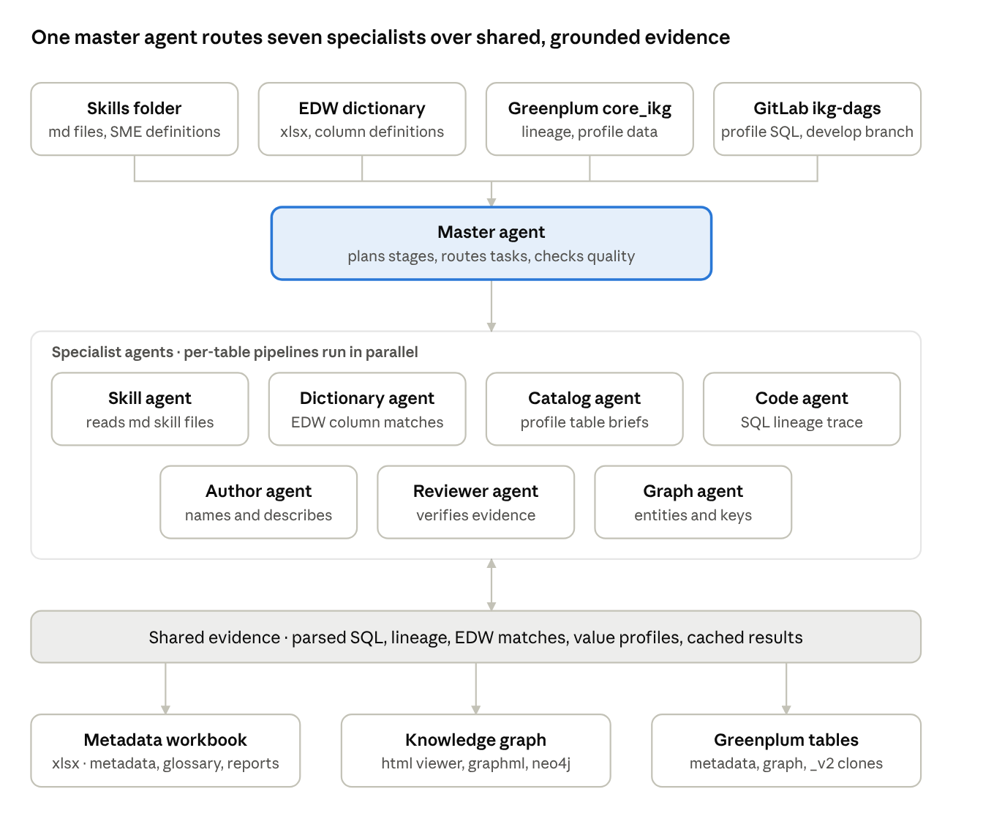
architecture · inputs, master agent, seven specialists, evidence store, outputs
Every agent reads and writes the same evidence store, so a description is only accepted when the reviewer can trace it back to a skill file, the SQL, lineage or the EDW dictionary.

The agents
One master agent plans the run and calls seven specialists through function tools; each specialist calls deterministic Python tools over one source and submits a result that code validates before it is accepted.
Agent | Understands | Tools it calls | Produces
Master | the whole program | run_skill_agent, run_dictionary_agent, run_table_pipelines, quality_report, run_graph_agent, write_outputs | the plan, quality gates, escalation of Low attributes
Skill | skills/*.md (firm knowledge) | list / read / search skills | verified definitions, abbreviations, column definitions (e.g. acc_mhh_n = statement household), authoring rules
Data Dictionary | EDW Data Dictionary, glossary | EDW lookup / search, token usage, repo search | meaning of every abbreviation token; unknown ones marked NEEDS_INPUT
Table Catalog | Greenplum catalogue, lineage table, actual values | catalogue, lineage walk, read-only value profiling | grain check, value profiles of flag / code columns
Code | GitLab ikg-dags SQL and Python | read profile script, find upstream writers, read any file, regex search, code lineage | table brief: purpose, grain, business rules quoted from SQL, time windows
Author | all evidence | evidence pack + every tool above on demand | business name, description, entity, type, unit, confidence per column
Reviewer | all evidence | same | verdict correct / revised / insufficient evidence, corrected text
Graph | entities and relationships | relationships with evidence, entity attributes, key columns | validated relationships, joining keys, entity descriptions

How one attribute gets its metadata
Every column is described from an evidence pack, never from its name alone. The pack is assembled by code before any model is called: the column's expression in the create script, the lineage walked upstream through ikg_column_lineage_master_auto_refresh, the filters on the way, the EDW definition of the source column, the glossary expansion of each name token, and any skill definition or value profile.
- The author agent receives the table's catalogue entry, the code agent's brief and the create script, plus the packs of 20 columns, and writes name, description, entity, type, unit and a confidence with its reason. It calls tools only where the pack is insufficient.
- Code validates the submission: allowed entity, unique names within the table, no unresolved abbreviation in a name; rejected items go back to the agent once, then are accepted with the issues recorded.
- The reviewer agent re-checks every attribute that is not High against the same evidence and may revise it.
- The confidence score is 0.6 × the model's rubric score + 0.4 × an evidence score (expression in code, lineage reached its source, EDW definition, abbreviations resolved, data type, catalogue entry). It is capped below High while an abbreviation is unresolved; Low attributes carry a concrete what_is_required.
- A column name that occurs in several tables is authored once and copied, so acc_mhh_n reads the same in all 55 tables.
Evidence priority is fixed: skill definitions, then what the SQL and lineage actually populate the column from, then EDW definitions, and the name tokens last.
A simpler case, account_profile_curr_ikg.has_acc_credit_card, shows why the lineage walk matters even for a plain pass-through column: the profile script only says a.has_acc_credit_card, and the rule that gives the flag its meaning (a credit-card record of type 'C' in the EDW account-card dimension) lives two hops upstream.
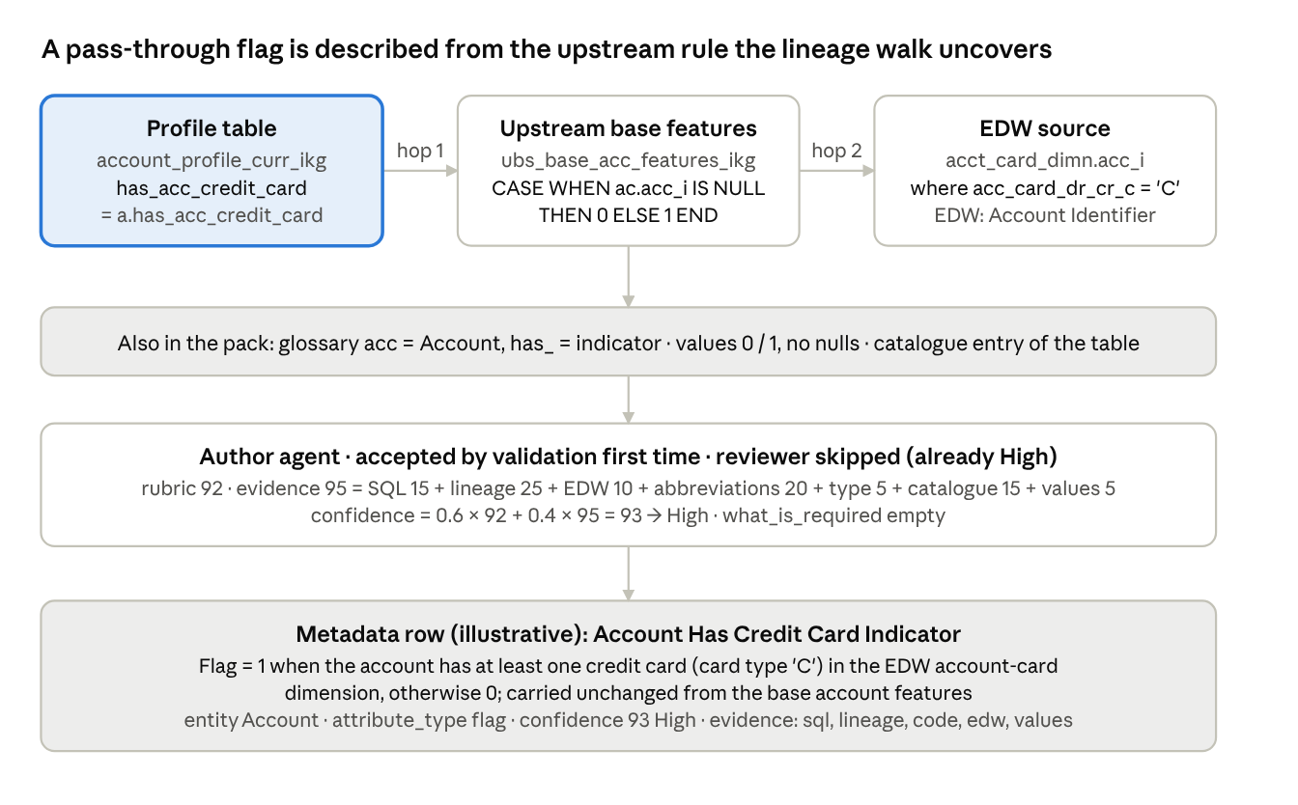
simpler example · has_acc_credit_card, a flag passed through from an upstream rule
The same pack then explains the derived columns beside it: is_loan_acct is CASE WHEN is_mortgage = 1 or is_sbl_flg = 1 or is_loc = 1 or has_acc_credit_card = 1, so its description can cite this flag by name.

Where the review step earns its keep
In plain terms: one agent writes a first draft from the clues, and a second agent checks that draft against the rule book before it is published. acc_mhh_n shows why that second look matters. The name piece mhh can be read two ways, and a draft written from the name alone picks the wrong one; the reviewer sees that the skill file and the lineage both say statement household and corrects it.
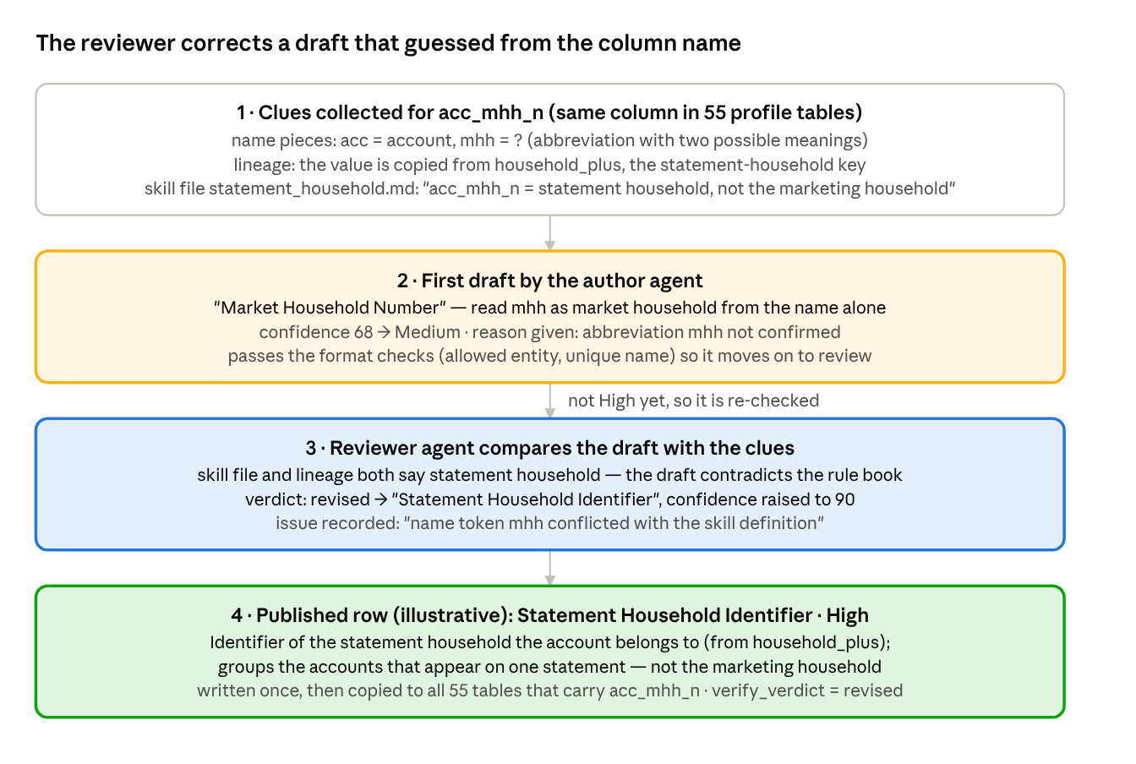
review example · acc_mhh_n, a draft corrected against the skill file
The correction is not lost in the sheet: the Metadata tab keeps verify_verdict = revised and the reason, so anyone can see which attributes were changed on review and why. Because the column name is shared, the corrected text is written once and reused in every table that carries it.

Accuracy safeguards
- Grounding quotes: a definition, abbreviation or SQL business rule is accepted only if the agent's quote is found verbatim in the skill file, the EDW dictionary or the repository. Otherwise it is downgraded to unknown, never used as fact.
- Two independent lineages: the lineage table walked upstream (PARTITION BY keys not followed, unqualified columns resolved) and a parser over all 928 repository scripts, with intermediate WHERE filters.
- Real values: flag and code columns are profiled read-only in Greenplum, so "1 = has SBL loan" is checked against the data.
- Gated master: the orchestrator cannot skip prerequisites (skills before dictionary before authoring) or finish before the outputs are written.
- Independent review plus escalation: Low attributes go back to the author with the reviewer's issues and an instruction to use the tools, at most twice.
- Audit trail: every agent turn and tool call is in the Agent_Trace sheet; every agent result is cached in JSON with the table and column names.
- SME loop: unknown abbreviations land on Glossary_Needs_Input; a one-line statement in a skill file (for example acc_mhh_n = statement household, sourced from household_plus) becomes authoritative for every table on the next run.

Run flow and performance
A run is the notebook IKG_Metadata_Agents.ipynb or python run_pipeline.py; secrets (Azure key, Greenplum password, GitLab token) are entered at run time and never stored.
- Data layer (no model): download the ikg-dags code from GitLab (branch develop), read the lineage table, ikg_profile_table_descriptions, information_schema and the EDW Data Dictionary, parse the 55 create scripts, build the evidence pack of every column and the base glossary. About 2 minutes.
- Delta comparison: deployed %profile_curr_ikg tables and columns against core_ikg.ikg_attribute_business_description; only new tables and columns go further (first run: everything).
- Skill agent, then dictionary agent (about 4 minutes for 670 tokens).
- Per-table pipelines, all tables concurrently: value profiling, code brief, author, review, escalation of Low. Stages overlap instead of waiting for the slowest table.
- Graph agent, workbook, knowledge graph, clone script, Greenplum loads.
Throughput is set by the Azure deployment's tokens-per-minute quota, not by the code. The client caps concurrent calls (12 by default), halves them on a 429, waits for Azure's Retry-After, learns the quota from the first 429 and paces below it, and retries a rate-limited request for up to 30 minutes so no batch is lost. Evidence is prefetched, so most agent tasks finish in one or two model turns; per-agent reasoning effort is low except for the code and author agents. Agent results are cached by input, so an interrupted or repeated run only redoes new work.

Outputs
Output | Where | Content
Metadata workbook | output/IKG_Profile_Attribute_Metadata.xlsx | Metadata (table_name, column_name, business_attribute_name, description, confidence score and band, entity, attribute type, unit, derivation type, confidence reason, difficult to generate, what is required, evidence used), Needs_Review, Glossary, Glossary_Needs_Input, Table_Briefs, Entity_Relationships, Joining_Keys, Clone_Report, Delta_Summary, Agent_Trace
Knowledge graph | output/knowledge_graph/knowledge_graph.html + pictures/ | interactive page (entities as nodes, attributes as leaves, relationships with evidence, search), one picture per entity, GraphML and Neo4j CSV
Business descriptions | core_ikg.ikg_attribute_business_description | created once; later runs append only new tables and columns
Graph tables | core_ikg.ikg_graph_relationship, core_ikg.ikg_graph_joining_key | relationships with evidence; joining key per relationship (Client to Household on acc_mhh_n, Account to Client on ip_cli_i) and the tables that carry it
Normalised clones | core_ikg.<table>_v2 and output/profile_table_clones.sql.txt | every profile table without the columns that duplicate another table's attributes (kept: own attributes, joining keys, technical columns); data identical for every kept column; Clone_Report lists each removed column with its owner table and joining key
Every table created gets owner erd_gp_db_prj_ikg and SELECT for erd_gp_db_prj_ikg_ro.

Demo script (10 minutes)
- Problem (1 min): open household_profile_curr_ikg in the catalogue; 688 columns such as mhh_cash_dist_4w_last_higher_d with no definition.
- Inputs (1 min): show the skills/ folder, the EDW Data Dictionary and the three Greenplum tables the program reads.
- Run (2 min): start the notebook on two pilot tables; point at the log lines: delta comparison, skill agent, dictionary agent, per-table pipeline with ETA.
- Evidence (2 min): open a cached agent JSON for one column, then the same column's Agent_Trace rows: which tools it called and why. Show the quote check rejecting a fabricated skill quote.
- Results (2 min): Metadata sheet, the confidence band colours, one Low attribute and its what_is_required; Glossary_Needs_Input.
- Graph and clones (2 min): the knowledge graph page (entity overview, drill into Household, search cash dist); Joining_Keys; Clone_Report for account_profile_curr_ikg (18 duplicated client and household columns removed, re-joinable on ip_cli_i and acc_mhh_n).
Talking points: nothing is written from a column name alone; every statement has a quote or a lineage behind it; SMEs correct the program by writing one sentence in a skill file; a second run costs only the new tables and columns.

